

**Department of Computer Science**

**1. CPSC 597 / 598 PROJECT / THESIS DEFINITION**

**To the graduate student:**

1. Complete a project proposal, following the department guidelines.
2. Have this form signed by your advisor and reviewer / committee.
3. Submit it with the proposal attached, to the Department of Computer Science.

Project



Thesis

Please print or type.

|  |  |  |  |  |  |
| --- | --- | --- | --- | --- | --- |
| Student Name: | Drashti Mehta | Student ID: | | 889212452 | |
| Address: | 14757 Blazing Star Drive, Eastvale, California 92880 | | | | |
|  | Street | City |  | Zip Code | |
| Home Phone: | 951-315-3100 | Work Phone: |  | | |
| E-Mail: | [dumehta@csu.fullerton.edu](mailto:dumehta@csu.fullerton.edu) | Units: | 3 | Semester: | Fall 2024 |

Are you a Classified graduate student? Is this a group project?



Yes

Yes

No



No

Proposal Date:

Tentative Date for Demonstration

/Presentation/Oral Defense: Completion Deadline:

Tentative Title: Artificial Intelligence in Patient Diagnosis

We recommend that this proposal be approved:

Signature

|  |  |  |
| --- | --- | --- |
| Faculty Advisor Kenneth Kung |  | 12/20/2024 |
| Printed name |  | Date |
| Faculty Reviewer |  |  |
| Printed name | Signature | Date |
| Faculty Reviewer |  |  |
| Printed name | Signature | Date |



**Artificial Intelligence in Patient Diagnosis**

**California State University Fullerton College of Engineering and Computer Science**

Under Subject Of

CPSC 589: Seminar in Computer Science

Submitted By:

Drashti Mehta ([dumehta@csu.fullerton.edu](mailto:dumehta@csu.fullerton.edu))

Under the supervision of Prof. Kenneth Kung

**Submission Date: December 18, 2024**

Table of Contents

1. Introduction 4

1.1 Background 4

1.2 Problem Domain 4

1.3 Papers Surveyed 5

1.4 Proposed Solution 7

2. Project Objectives 7

3. Project Activities 8

Development Phases, Tasks, Activities and Deliverables 8

Phase 1: Research and Gathering Resources 8

Phase 2: Data Collection and Preprocessing 8

Phase 3: Model Selection and Training 8

Phase 4: Model Validation and Testing 9

Phase 5: System Deployment 9

4. Software Requirement Specifications 9

Functional Requirements: 9

Non-Functional Requirements: 10

Constraints: 10

5. Environment 10

6. Project Results 10

7. Project Schedule 11

8. Bibliography 14

# Introduction

# Background

Diagnostic testing has evolved during the past century into a crucial aspect of contemporary medical practice. Gathering, combining, and interpreting data takes place in cycles, with each cycle improving the working diagnosis. Diagnostic testing can occasionally identify problems before they display clinical symptoms. For example, imaging investigations might identify artery blockages that are suggestive of coronary artery disease in people who do not exhibit any symptoms.

Clinicians frequently encounter difficulties in diagnosing patients due to the intricate and iterative nature of the diagnostic process. It starts when a patient interacts with medical professionals after experiencing a health problem. The doctor begins obtaining, combining, and analyzing data to reach a practical diagnosis. During this process, a clinical history is obtained, physical examinations are performed, diagnostic tests are ordered, and other medical specialists are occasionally consulted. Refined assumptions regarding the patient's condition result in diagnostic revision and verification as new information is available [1]. Physicians try to eliminate uncertainty, rather than giving a patient guaranteed diagnostic certainty because complete certainty on a complex diagnosis is nearly impossible.

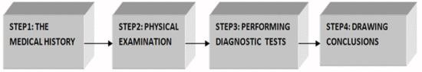

*Figure 1: Block diagram of the diagnosis process.[4].*

# Problem Domain

The uncertainty that surrounds the diagnostic process presents clinicians with substantial hurdles when diagnosing patients. Clinicians start a difficult, iterative process of obtaining, combining, and analyzing data as soon as a patient seeks care to develop a working diagnosis. Throughout this procedure, one of the main concerns is whether enough data has been gathered to move on with a diagnosis. However, as Balogh highlighted, absolute certainty is rarely attainable, “A diagnosis is a hypothesis about the nature of a patient’s illness... Our task is not to attain certainty, but rather to reduce the level of diagnostic uncertainty enough to make optimal

therapeutic decisions” [1]. The end goal is to reduce uncertainty for patients.

Artificial Intelligence (AI) has been transforming the healthcare industry, especially in diagnostic support. AI has the capacity to remain constant and unaffected by external circumstances, which makes it an effective tool for lowering diagnostic uncertainty and enhancing the accuracy of medical judgments [2]. The amount of daily medical data is much for human clinicians to handle. AI systems can effectively sort through this enormous amount of data, finding correlations and patterns humans often overlook. AI can provide real-time analysis, increase diagnostic accuracy, and help physicians make evidence-based decisions. With this, medical professionals can improve patient outcomes and lower diagnostic mistake rates. The illustration below shows how AI and machine learning models can be used to enhance diagnostic accuracy in the healthcare industry while addressing the problems that doctors naturally confront, like exhaustion, biases, and information overload [5].

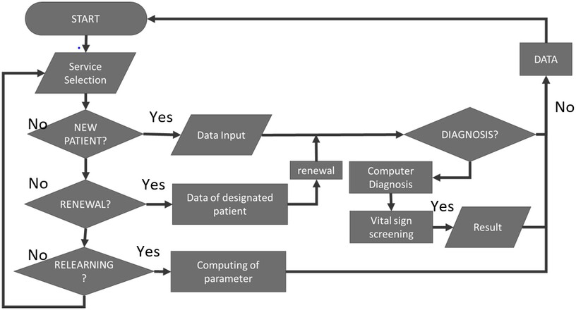

*Figure 2: Flowchart of Automated Diagnosis [5].*

The following are the key issues of existing or previous automated AI Diagnosis systems:

**High costs:** Creating and maintaining advanced AI systems can be quite costly, requiring large expenditures on data collection, research, and development.

**Privacy concerns**: Fears of possible data mismanagement or illegal sharing may prevent healthcare providers from implementing AI technologies.

**Regulatory Challenges**: The adoption of AI technologies has major obstacles due to the highly regulated healthcare industry, which also complicates compliance with numerous standards and requirements.

**Evaluation Technique:** Current evaluation techniques do not accurately reflect real-world practices; more research needs to be done on real diagnosis and decision-making with AI.

**Privacy and Robustness:** Maintaining the safety and dependability of AI systems in clinical contexts requires addressing privacy concerns and making sure they are resilient.

# Papers Surveyed

Existing AI diagnosing systems, such as IBM's Watson and Google's AMIE, have experienced setbacks despite promising initial findings, highlighting the need for more sophisticated models and ongoing studies into AI's reliability. IBM Watson struggled with system integration, high prices, and overpromised capabilities, frequently failing to give clinically appropriate recommendations due to data limitations and scalability concerns. AMIE, on the other hand, was constrained by its reliance on high-quality annotated data, a lack of clinical validation, and algorithmic constraints in dealing with complex medical problems. These challenges highlight the importance of AI systems that are versatile, cost-effective, and proven for real-world clinical applications.

Paper 1: “How IBM Watson Overpromised and Underdelivered on AI Health Care [4].

Summary: This article examines IBM Watson's inadequacies and difficulties in the healthcare industry. It demonstrates the considerable obstacles that Watson's early claims of being able to diagnose illnesses and customize treatment regimens had to overcome in practical implementations. Watson struggled with problems relating to data quality, integration into clinical workflows, and eventually failed to offer consistent and dependable outcomes in patient care, despite its sophisticated algorithms and extensive data processing capabilities [4].

Analysis: Watson’s natural language processing (NLP) abilities gave it the ability to spot trends in enormous datasets. This was a major advancement in artificial intelligence. Nevertheless, IBM encountered significant obstacles in its healthcare pursuits. Though there was initial hope, Watson was harshly criticized by specialists for making possibly harmful recommendations”

[4]. Moreover, Watson's performance in real-world applications varied because of

the complexity of EHRs, which included problems including unclear entries and missing data, which made it difficult for Watson to extract insightful information. Its acceptance was hindered by high development and maintenance costs, privacy concerns, and regulatory obstacles.

Healthcare professionals were doubtful about the system's advantages, and it had trouble blending in with clinical procedures. In the end, Watson Health fell short of the revolutionary effect it had once predicted.

Paper 2: “AMIE: A Research AI System for Diagnostic Medical Reasoning and Conversations” [3].

Summary: AMIE is an “LLM-based conversational diagnostic research AI system” [3]. Its goals are to improve medical diagnostic reasoning and ease communication between patients and physicians. By analyzing patient data and medical literature, AMIE uses cutting-edge natural language processing and deep learning algorithms to produce medical suggestions and insights that are contextually relevant. By giving doctors evidence-based information customized to patient circumstances, the system seeks to increase the effectiveness and accuracy of clinical decision-making and diagnosis [3].

Analysis: AMIE makes use of a large language model (LLM) that has been tuned to comprehend clinical scenarios in a variety of specializations and disease states. The researchers developed a self playing simulated diagnostic discussion environment with automatic feedback mechanisms to help AMIE learn on a larger scale. Results of the study point to the possibility of real-time clinical applications for AI such as AMIE, which can be trained well with a mix of simulated and real-world data. As shown in the figure below, when compared to actual primary care physicians (PCPs), AMIE performed better in terms of diagnosis accuracy and performance on the majority of consultation quality axes. Across 149 scenarios, AMIE consistently outperformed PCPs in terms of top-k diagnostic accuracy, both in the accepted differential diagnoses and the ground truth diagnosis [3]. These findings imply that AMIE can offer diagnostic assistance in a range of clinical settings that is on par with or better than human performance.

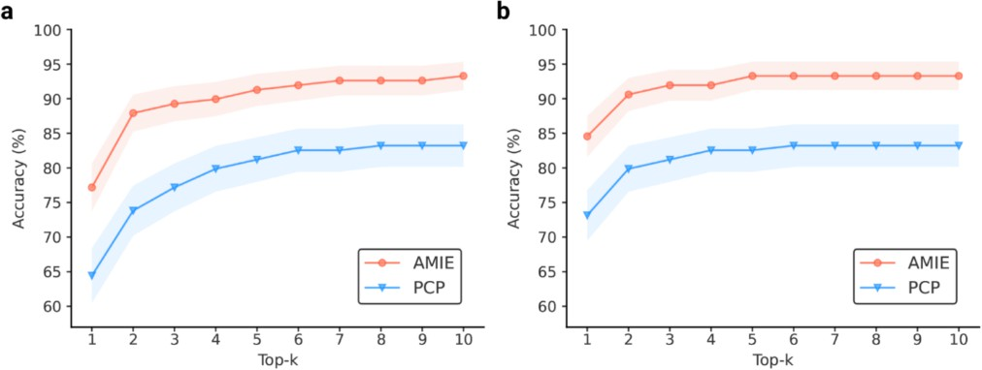

*Figure 3: Specialist-rated top-k diagnostic accuracy [3].*

AMIE performed better than real doctors in simulated medical consultations, indicating its potential to improve patient care and diagnostic accuracy. It is still difficult to apply these findings to actual clinical settings, though, because the system must be tested in real-world scenarios and must guarantee fairness and health equity.

# Proposed Solution

I intend to solve these limitations of previous AI diagnostic systems using several strategies. I will incorporate various, high-quality open-source datasets to improve the AI models' reliability and accuracy, guaranteeing they can manage a range of clinical circumstances. I will establish interoperability standards to ensure that the system integrates seamlessly with other electronic health record (EHR) systems, making it more scalable and easier to use across healthcare facilities. The system will be validated against small-scale, publicly available datasets or simulated scenarios. To make the system more accessible, I plan to use cost-effective deployment options, such as cloud-based platforms, to lower financial barriers for healthcare providers.

# Project Objectives

The ultimate objective of this project is to create a program application that leverages AI to improve diagnostic accuracy and reduce clinical uncertainty in healthcare. Since earning my bachelor's degree, I have worked in the healthcare industry, notably in the technology sector. This subject has always piqued my interest because of the convergence between clinical practice and technological innovation. Throughout my career, I've seen firsthand the complications that clinicians encounter when making diagnostic judgments, as well as the limits of traditional methodologies such cognitive biases, data overload, and scalability issues. These problems frequently contribute to diagnostic errors, affecting patient outcomes.

My goal with this project, is to create an accessible AI diagnostic system that addresses these crucial difficulties by providing clinicians with real-time, AI-driven insights that can enhance diagnostic accuracy, particularly in complex and uncertain cases. By leveraging high-quality, open-source medical datasets and AI models, this system will address key challenges such as cognitive biases, data overload, and integration limitations found in existing AI diagnostic systems. The significance of this project lies in its potential to improve patient outcomes by offering clinicians a reliable, scalable, and cost-effective tool that reduces diagnostic errors and supports more informed decision-making. It is important to note that this system will be designed not to replace healthcare workers but to serve as a valuable resource that complements their expertise.

# Project Activities

# Development Phases, Tasks, Activities and Deliverables

This project will have five development phases. I will include these phases in my project timeline, which will be detailed at the end of this paper.

# Phase 1: Research and Gathering Resources

Tasks & Activities:

* Identify and acquire cloud-based computing resources such as AWS, Google Cloud, and Azure to support AI model training and testing.
* Research AI frameworks such as TensorFlow and PyTorch, looking at their potential applications in medical diagnostics.
* Set up development environments, such as Jupyter notebooks, version control system Git, and required libraries.
* Enroll in online courses and watch tutorials to improve skills in data preprocessing, model training, and evaluation for healthcare activities.

Deliverables:

* A cloud-based infrastructure AWS/Google Cloud for handling massive medical datasets.
* A well-organized technical environment featuring Jupyter notebooks and version control tools.
* Access to AI model frameworks TensorFlow, PyTorch and related libraries.
* A collection of completed tutorials and tools that demonstrate knowledge of AI model creation for healthcare applications.

# Phase 2: Data Collection and Preprocessing

Tasks & Activities:

* Data Acquisition: Collect high-quality, publicly available medical datasets from sites like Kaggle, the UCI Medical Repository, and clinical data repositories.
* Data Cleaning and Preprocessing: To assure consistency and accuracy, normalize, remove outliers, and use data augmentation techniques.
* Data Annotation: Find relevant features including symptoms, diagnoses, and patient demographics.
* Data Integration: Combine various datasets into a single format, ensuring that they are consistent with clinical situations for efficient model training.

Deliverables:

* A set of well-preprocessed and labeled datasets appropriate for model training.
* A clean and consistent dataset, ready for model input.
* Documentation of data pretreatment steps and modifications applied.

# Phase 3: Model Selection and Training

Tasks & Activities:

* Model Selection: Choose AI models such as CNNs, RNNs, Transformer models based on the diagnostic task's complexity and nature.
* Experiment with alternative hyperparameter values to improve model performance
* Model Training: Run selected models on preprocessed data to ensure scalability and efficiency in a cloud setting.
* Model Evaluation: Measure the trained models' accuracy, precision, recall, and F1-score to ensure they meet clinical performance standards.

Deliverables:

* AI models have been trained using proven performance indicators.
* A collection of hyperparameter tuning studies and optimal configurations.
* Model evaluation reports document performance metrics and diagnostic accuracy.

# Phase 4: Model Validation and Testing

Tasks & Activities:

* Validation Setup: Conduct small-scale validation tests on publicly available datasets or simulated clinical situations.
* Cross-Validation: Use k-fold cross-validation to evaluate model performance and assure generalizability across data splits.
* Clinical Simulation Validation: Utilize simulated clinical environments to validate the models against predefined clinical criteria and patient scenarios.
* Model Refinement: Refine models using validation feedback and clinical insights, iterating on the model architecture as appropriate.

Deliverables:

* A report on validation outcomes, including performance indicators from cross-validation and clinical simulation validation.
* Updated model versions incorporate feedback from simulated clinical contexts. Documentation for model refining methods and clinical simulation findings.
* A well-documented validation methodology with results for future reference.

# Phase 5: System Deployment

Tasks & Activities:

* System Deployment: To ensure scalability and ease of access, deploy the AI models on cloud-based platforms such as AWS and Azure.
* Interoperability: Use FHIR-compliant APIs to integrate with EHR systems and ensure seamless data transmission.
* Documentation and Training: Provide user documentation and tutorials to assist users in efficiently implementing the system.

Deliverables:

* A fully functional AI diagnostic system running on cloud platforms.
* FHIR-compliant APIs and EHR integration documentation.

# Software Requirement Specifications

The following are the functional, and non-functional requirements, and constraints.

# Functional Requirements:

* Support for FHIR-compliant EHR integration.
* Access to high-quality, open-source medical datasets.
* Use of machine learning frameworks such as TensorFlow and PyTorch for model training.
* Development of deep learning and ensemble models for diagnostic accuracy.
* A web-based or mobile interface for clinicians to interact with the system.
* Visual feedback and diagnostic insights presented in a clear, interpretable format.
* Validation against simulated clinical environments and publicly available datasets.

# Non-Functional Requirements:

* The system must scale to support large healthcare facilities and various clinical environments.
* Efficient handling of high-volume data.
* The system must achieve a high diagnostic accuracy rate, with an acceptable margin of error.
* Maintainability of models to adapt to evolving clinical data.
* Cloud-based deployment to reduce hardware and infrastructure costs.
* Utilization of open-source tools and data to minimize licensing expenses.
* Adherence to HIPAA regulations for data security and patient privacy.
* Secure access controls and encrypted data transmission.

# Constraints:

* Dependency on the quality and availability of open-source clinical datasets.
* Limited access to real-world clinical data may require reliance on simulated environments.
* Limited computational resources for training large-scale AI models in some healthcare settings.
* Ensuring FHIR compliance for data exchange could be technically challenging.

# Environment

Programming Language: Python Python Libraries:

* TensorFlow
* PyTorch
* NumPy
* Pandas
* Scikit-Learn
* Tkinter
* OpenCV

Hardware:

* System: Laptop/Computer

Software:

* Integrated Development Environment (IDE): Visual Studio Code
* Operating System: Windows, macOS, or Linux
* Database: SQLite or cloud-based storage for model validation data.

# Project Results

The final product will have a user-friendly graphical user interface (GUI) created with Python and modules like Tkinter. This UI will enable users to interface with the diagnostic system, enter patient data, and receive real-time diagnostic recommendations. The UI will be intuitive, making it easy to use for all individuals.

When the data is entered, the system processes it in real time to produce accurate diagnostic recommendations that are presented in a simple and plain manner. The design would emphasis an intuitive layout to enable accessibility for non-technical users, such as healthcare professionals with little technical knowledge. The interface will also include visual indicators such as progress bars and fault warnings to improve the user experience. Overall, the GUI will be crucial in making advanced AI diagnostics accessible and efficient to a diverse variety of users.

The deliverables are evaluated based on usability testing findings, with a goal of achieving at least 85% user satisfaction among a sample of non-technical healthcare practitioners and achieving at least 80-90% diagnostic accuracy. Additional criteria will be used to assess system correctness and efficiency, such as diagnostic recommendation processing time.

To enhance the project's long-term potential, for future work, there will be an incorporation of new features such as multilingual support, compatibility with a variety of electronic health record (EHR) systems, and advanced predictive analytics. Timelines and possible collaborations with healthcare providers or private healthcare companies will be highlighted to help steer the system's progress and scalability. The goal of this project is to provide the groundwork for future advancements in AI-powered medical diagnosis.

# Project Schedule

|  |  |  |  |
| --- | --- | --- | --- |
| **Task/Phase** | **Description** | **Estimated Hours** | **Milestones** |
| **Phase 1: Research and Gathering Resources (Weeks 1-4)** | Identify cloud-based computing resources, AI frameworks, and set up development environments. | 30 | Cloud infrastructure and tools setup complete |
| **- Identify cloud resources** | AWS, Google Cloud, Azure setup | 8 | Cloud resources configured |
| **- Research AI frameworks** | TensorFlow, PyTorch | 8 | AI framework research complete |
| **- Set up development tools** | Jupyter notebooks, Git, libraries | 6 | Development environment fully functional |
| **- Online courses and tutorials** | Data preprocessing, model training, evaluation | 8 | Tutorials completed |
| **Phase 2: Data Collection and Preprocessing (Weeks 5-9)** | Collect, clean, and preprocess medical datasets | 40 | Preprocessed dataset ready for training |
| **- Data Acquisition** | Collect high-quality medical datasets from  Kaggle, UCI, clinical data repositories | 12 | Datasets collected |
| **- Data Cleaning & Preprocessing** | Normalize, remove outliers, apply data augmentation | 10 | Preprocessed and consistent dataset |
| **- Data Annotation** | Tag relevant features (symptoms, diagnoses, patient demographics) | 8 | Annotated and ready for model training |
| **Phase 3: Model Selection and Training (Weeks**  **10-12)** | Select models, tune hyperparameters, and train models | 50 | Trained models ready for evaluation |
| **- Model Selection** | CNNs, RNNs,  Transformers based on diagnostic task complexity | 12 | Selected models aligned with requirements |
| **- Experiment Hyperparameters** | Tune hyperparameter values for optimal performance | 15 | Optimal hyperparameter configurations determined |
| **- Model Training** | Run models on preprocessed data | 20 | Trained models achieve clinical performance targets |

|  |  |  |  |
| --- | --- | --- | --- |
| **- Model Evaluation** | Measure accuracy, precision, recall, F1-  score | 3 | Performance metrics documented |
| **Phase 4: Model Validation and Testing (Weeks 13-16)** | Validate models in clinical scenarios and refine based on feedback | 50 | Validated models that meet clinical standards |
| **- Validation Setup** | Small-scale tests on clinical/simulated data | 10 | Validated models meet clinical criteria |
| **- Cross- Validation** | K-fold cross-validation for generalization | 10 | Model performance validated |
| **- Clinical Simulation** | Simulated clinical environments for validation | 15 | Models meet user benchmarks |
| **- Model Refinement** | Iterative improvements using feedback | 5 | Refined models ready for deployment |
| **Phase 5: System Deployment (Week 17)** | Deploy system and integrate with EHR systems | 30 | Fully functional AI diagnostic system |
| **- System Deployment** | Deploy on cloud platforms (AWS, Azure) | 15 | System operational on cloud environments |
| **- Interoperability** | Integrate with FHIR- compliant APIs/EHR systems | 8 | EHR integration complete |
| **- Documentation & Training** | Provide user guides, tutorials, and training | 7 | User documentation and training complete |

*Table 1: Project Schedule*

Total Estimated Hours: 190 hours

# Bibliography

1. Balogh, E. P., Miller, B. T., & Ball, J. R. (2015, December 29). The diagnostic process. Improving Diagnosis in Health Care - NCBI Bookshelf. <https://www.ncbi.nlm.nih.gov/books/NBK338593/>
2. Harada, T., Shimizu, T., Kaji, Y., Suyama, Y., Matsumoto, T., Kosaka, C., Shimizu, H., Nei, T., & Watanuki, S. (2020). A Perspective from a Case Conference on Comparing the Diagnostic Process: Human Diagnostic Thinking vs. Artificial Intelligence (AI) Decision Support Tools. International Journal of Environmental Research and Public Health, 17(17), 6110. <https://doi.org/10.3390/ijerph17176110>
3. Karthikesalingam, Alan and Natarajan, Vivek (2024, January 12). AMIE: A research AI system for diagnostic medical reasoning and conversations. [https://research.google/blog/amie-a-research-ai-system-for-diagnostic-medical-reasoning-](https://research.google/blog/amie-a-research-ai-system-for-diagnostic-medical-reasoning-and-conversations/) [and-conversations/](https://research.google/blog/amie-a-research-ai-system-for-diagnostic-medical-reasoning-and-conversations/)
4. Strickland, E. (2019). How IBM Watson overpromised and underdelivered on AI health care. IEEE Spectrum. [https://spectrum.ieee.org/how-ibm-watson-overpromised-and-](https://spectrum.ieee.org/how-ibm-watson-overpromised-and-underdelivered-on-ai-health-care) [underdelivered-on-ai-health-care](https://spectrum.ieee.org/how-ibm-watson-overpromised-and-underdelivered-on-ai-health-care)
5. Zaki, W. M. a. W., Shakhih, M. F. M., Ramlee, M. H., & Wahab, A. A. (2019). Smart Medical Chatbot with Integrated Contactless Vital Sign Monitor. Journal of Physics Conference Series, 1372(1), 012025. <https://doi.org/10.1088/1742-6596/1372/1/012025>